THE DESIGN PROCESS
Your Study Guide

Grade 8 ICT & Design — Term 1

From empathy to app — everything you need to know, in one place.

How to Use This Guide

This guide isn't organized week by week — it's organized by big idea, so you can use it to review any concept from the whole unit in one place, in any order.
Every chapter follows the same pattern:
Big Idea — the one sentence that matters most.
Key Terms — the vocabulary you need to know, in plain language.
Did You Know? — a real-world connection to make the idea stick.
Try This — a quick, low-stakes activity to practice the idea yourself.
Quick Check — questions to test whether it's really sunk in.

MEET TEAM STUDYBUDDY
Throughout this guide, we'll follow one running example: a team of students designing a homework-help app called StudyBuddy, from their very first conversation with a real user all the way to their final presentation. It's a made-up team, but every step they take is exactly the process you're using in your own project — use their journey to see each idea in action.

What's Inside

Chapter 1 Empathy & Understanding Your User
Chapter 2 Define & Prepare
Chapter 3 Prototyping Your First Idea
Chapter 4 User Interfaces & Usability
Chapter 5 Using Feedback to Improve
Chapter 6 Finding Real User Needs Through Interviews
Chapter 7 Building & Testing Your Paper Prototype
Chapter 8 Apps for Good & Market Research
Chapter 9 UI Elements in Your App
Chapter 10 From Paper to Digital: App Lab
Chapter 11 Events, Debugging & Presenting Your App
+ The Design Process Recap · Full Glossary · Are You Ready to Present? · Closing Note

 | CHAPTER 1  Empathy & Understanding Your User

Great design doesn't start with an idea. It starts with a person.
Meet Team StudyBuddy — a group of students who spent this whole term designing a real app, from a blank page to a working prototype. We'll follow their journey through every chapter of this guide.
Before Team StudyBuddy wrote a single line of code, they didn't ask “what should our app do?” They asked “who needs help, and with what?” They talked to classmates who said homework felt overwhelming and hard to track. That one conversation shaped everything that came next — because empathy means understanding what someone else actually needs, not what you'd guess they need.
KEY TERMS
Empathy — understanding and sharing another person's feelings or perspective.
User — the person a product or design is actually made for.
Need — something a user requires from a product for it to actually work for them.
User Profile — a description of a specific person's age, abilities, habits, and needs.
Perspective — seeing a situation from someone else's point of view.
Inclusive — designed to work well for as many different kinds of people as possible.
Accessibility — how easily a product can be used by people with different abilities.
Evidence — specific facts or details that support a design decision.

DID YOU KNOW? The OXO Good Grips kitchen tools were originally designed for people with arthritis, who needed easy-to-grip handles. Turns out — everyone loved them. Designing for one specific user's real need often makes a product better for everyone.
TRY THIS Ask someone at home about one small thing that annoys them every day (opening a jar, remembering a password, finding their keys). Write down their need in one sentence — not your guess, their actual words.
QUICK CHECK
1. What's the difference between a “need” and a “want”?
2. Why might designing for a specific user (not “everyone”) actually make a product better for more people?

 | CHAPTER 2  Define & Prepare

You can't solve a problem you haven't clearly named.
Team StudyBuddy had a pile of sticky notes full of possible needs — reminders, motivation, finding study partners, tracking grades. Instead of trying to fix everything, they grouped similar ideas into categories, then picked ONE focus need: “Students forget what homework is due and when.”
That focus became their design criteria: whatever they built had to show upcoming homework clearly, in one place.
KEY TERMS
Define — clearly stating what problem you're solving and for whom.
Brainstorm — generating as many ideas as possible without judging them yet.
Category — a group of related ideas or items, organized to be easier to think about.
Criteria — the specific standards a solution needs to meet to be successful.

DID YOU KNOW? In real brainstorming sessions, the rule is: no judging ideas yet. Research shows judging ideas too early kills good ones before they've had a chance to develop.
TRY THIS Pick a problem you actually have this week. Brainstorm 5 possible directions without judging any of them. Then pick your favorite and write one sentence explaining what a good solution would need to do.
QUICK CHECK
1. What's the difference between brainstorming and defining?
2. Why sort sticky notes into categories before choosing a focus need?

 | CHAPTER 3  Prototyping Your First Idea

The fastest way to a good idea is a lot of rough ones.
Team StudyBuddy didn't wait until they had the “perfect” app idea. They sketched a rough, quick version — a prototype — of a homework tracker screen, labeled which parts solved their focus need, and showed it to classmates.
The first version wasn't good. That was the point: it was fast to make and fast to learn from.
KEY TERMS
Prototype — an early, rough version of a design built to test an idea.
Iteration — making a design better through repeated rounds of trying and improving it.
Feedback — specific, useful comments from someone else about how well something is working.
Design Rationale — the reasons behind a design decision — the WHY, not just the WHAT.

DID YOU KNOW? A famous design firm once had teams build a shopping-cart prototype out of foam, wire, and tape in one afternoon — not because it looked good, but because testing a rough idea fast beats planning a perfect one slowly.
TRY THIS Sketch a rough “prototype” of anything — a poster, a room layout, a game rule — in under 5 minutes. Don't erase mistakes. Just get the idea down.
QUICK CHECK
1. Why would a designer intentionally make a “rough,” not-perfect prototype?
2. What's the difference between feedback and design rationale?

 | CHAPTER 4  User Interfaces & Usability

If people can't figure out how to use it, it doesn't matter how good the idea is.
When Team StudyBuddy tested their paper prototype, one partner acted as the “app” while another tried to complete a real task — find tomorrow's homework. The tester got stuck: too many buttons, no clear way back.
That's a usability problem, not a bad idea — the interface just needed to be clearer.
KEY TERMS
User Interface — the screens, buttons, and controls a person sees and touches.
Usability — how easy and pleasant something is to actually use.
Navigation — how a user moves between different screens or sections of an app.
Screen — one individual view or page within an app.

DID YOU KNOW? Good navigation usually means a user should never wonder “where am I?” or “how do I get back?” If they have to guess, the interface needs work — not the user.
TRY THIS Open any app you use often. Try to find one specific feature you rarely use. Notice how many taps it takes, and whether you ever feel lost.
QUICK CHECK
1. What's the difference between a good idea and a usable interface?
2. Name one part of a UI that helps with navigation.

 | CHAPTER 5  Using Feedback to Improve

Feedback isn't criticism — it's data.
After testing, Team StudyBuddy had a pile of sticky-note feedback: “confusing button,” “love the color,” “missing a way to mark homework done.”
They sorted it into categories, found the most common issue, and prioritized fixing that one first instead of trying to fix everything at once.
KEY TERMS
Prioritize — deciding what to work on first based on what matters most.
Revise — changing something to make it better, based on feedback.
I Like / I Wish / I Wonder — a feedback protocol that keeps critique specific and kind.

DID YOU KNOW? “I Like / I Wish / I Wonder” is used far beyond classrooms — real product teams at tech companies use almost the exact same structure to keep feedback specific and kind instead of just “this is bad.”
TRY THIS Next time a friend shows you something they made, try responding with one “I like,” one “I wish,” and one “I wonder” instead of just “looks good.”
QUICK CHECK
1. Why sort feedback into categories before acting on it?
2. What does it mean to “prioritize” feedback?

 | CHAPTER 6  Finding Real User Needs Through Interviews

The best app ideas come from listening, not guessing.
Team StudyBuddy read through interview notes from real students. One line stood out: “I always remember at 9pm that I have math homework due tomorrow.”
That single sentence was evidence of a barrier (forgetting) and an opportunity (a reminder that actually gets noticed) — and it became the seed of their whole app idea.
KEY TERMS
Interview — asking someone questions directly to learn about their needs or habits.
Barrier — something that gets in the way of a user doing what they need to do.
Opportunity — a chance to solve a problem or make something better for a user.
Insight — a useful realization about a user that explains why they need something.
App Idea — a specific concept for an app that solves a real need for a real user.

DID YOU KNOW? Just guessing what someone needs is risky — studies on failed products consistently point back to teams who skipped talking to real users and designed based on assumptions instead.
TRY THIS Ask someone a genuinely open question — “what's the most annoying part of your day?” — and just listen. Don't suggest a solution. Write down their answer word-for-word.
QUICK CHECK
1. What's the difference between a barrier and an opportunity?
2. Why does an app idea need to be linked to a specific need, not just be “cool”?

 | CHAPTER 7  Building & Testing Your Paper Prototype

Test it before you build it — paper is cheaper to fix than code.
Team StudyBuddy built every screen of their app idea out of paper before touching a computer. They mapped the screen flow — how a user moves from screen to screen — then swapped prototypes with another team and watched someone else try to use it.
That's when they discovered their “Add Homework” button was impossible to find.
KEY TERMS
Paper Prototype — a version of an app made entirely out of paper, used to test an idea.
Screen Flow — the path a user follows moving from one screen to the next.
Test — having a real person try to use your design so you can see what works.
Stakeholder — anyone who has an interest in or is affected by a project.

DID YOU KNOW? Paper prototyping is a real, professional practice — many app and game studios still test ideas on paper first because it's fast and cheap to change before any code is written.
TRY THIS Draw 3 connected screens of an app idea on paper (even a made-up one). Add arrows showing how a user moves between them.
QUICK CHECK
1. Why test a paper prototype before building anything digital?
2. Who is a “stakeholder” in a school app project?

 | CHAPTER 8  Apps for Good & Market Research

Before you build, check what already exists — and ask who it's really for.
Team StudyBuddy looked at existing homework apps. Some were cluttered with ads, some required a paid account, some didn't work offline.
That research didn't discourage them — it showed exactly what their app could do differently, and reminded them to think about who might be left out, like students without reliable internet.
KEY TERMS
Apps for Good — apps designed specifically to help solve a real problem, not just for profit.
Responsible — making design choices that consider the wellbeing and rights of users.
Market Research — looking at what already exists to understand what works and what's missing.
Competitor — an existing app or product that solves a similar problem to yours.
Ethical — doing what's right and fair, especially with users and their information.

DID YOU KNOW? “Apps for good” isn't just a school project idea — it's a real, growing category of technology built specifically to solve social or community problems, not just to make money.
TRY THIS Pick an app you use. Name one competitor app that does something similar, and one thing your app does better.
QUICK CHECK
1. Why research competitor apps before designing your own?
2. What makes an app idea “responsible,” not just “cool”?

 | CHAPTER 9  UI Elements in Your App

Every button, box, and icon on a screen should earn its place.
When Team StudyBuddy planned their screens, they didn't just add elements randomly. Each button, text input, and icon had a job — and they used visual hierarchy (size, position, color) to make sure the most important thing on each screen was the first thing a user noticed.
KEY TERMS
Button — a UI element a user taps or clicks to trigger an action.
Text Input — a UI element where a user types information into an app.
Dropdown — shows a list of options when tapped, letting a user pick one.
Icon — a small picture or symbol representing an action or piece of information.
Visual Hierarchy — arranging elements so the most important thing is noticed first.

DID YOU KNOW? Designers often test visual hierarchy by squinting at a screen — if you can still tell what the most important element is when it's blurry, the hierarchy is working.
TRY THIS Look at any app screen. Which element is biggest, boldest, or most colorful? Is that the thing you're actually supposed to notice first?
QUICK CHECK
1. Name a UI element you'd use to let a user pick from a list of options.
2. What is “visual hierarchy” for?

 | CHAPTER 10  From Paper to Digital: App Lab

This is where your paper prototype becomes a real, working screen.
With a tested paper prototype in hand, Team StudyBuddy opened Code.org's App Lab and used Design Mode to recreate their screens for real — dragging in buttons and text, matching what they'd already tested on paper.
Nothing here was a guess anymore; it was already user-tested.
KEY TERMS
App Lab — the Code.org tool used to build real, working apps.
Design Mode — the part of App Lab where you build a screen's visuals before adding code behavior.

DID YOU KNOW? Design Mode in App Lab is deliberately separate from the code — you build what a screen looks like first, then add what happens when someone taps something. Real app development often works the same way.
TRY THIS Before your next App Lab session, sketch (on paper) exactly what you plan to build digitally. Compare the two when you're done.
QUICK CHECK
1. Why build a paper prototype before opening App Lab?
2. What does Design Mode let you build?

 | CHAPTER 11  Events, Debugging & Presenting Your App

A working app is screens connected by events — and a few bugs along the way.
Team StudyBuddy linked their screens with events — tapping a button now actually took you to the next screen. Along the way, things broke: a button that led to the wrong screen, text that didn't fit. That's debugging — finding and fixing what's not working yet, not a sign something went wrong.
By the final week, they didn't just show their app — they presented their whole journey: the user need, what they learned from feedback, what bugs they fixed, and what they'd still improve.
KEY TERMS
Event — something a user does (like tapping a button) that tells the app to respond.
Link (Screens) — connecting one screen to another so tapping something moves the user.
Debug — finding and fixing something that isn't working correctly.
Bug — something in your app that doesn't work the way it's supposed to.
Feature — something your app does or offers, whether finished yet or not.
Presentation — sharing your work and explaining your process to an audience.
Reflection — thinking back on what worked, what didn't, and what you'd change.

DID YOU KNOW? The word “bug” in computing dates back to a real moth found stuck in an early computer in 1947 — the term stuck, and so did the practice of calmly hunting down what's broken instead of panicking about it.
TRY THIS Next time something you make doesn't work right away — a game, code, a recipe — call it a “bug to debug” instead of a failure. Notice if that changes how you approach fixing it.
QUICK CHECK
1. What's the difference between a bug and a feature?
2. Why does a good presentation include what DIDN'T work, not just the final result?

The Design Process, All Together
Every chapter in this guide is one piece of this cycle.

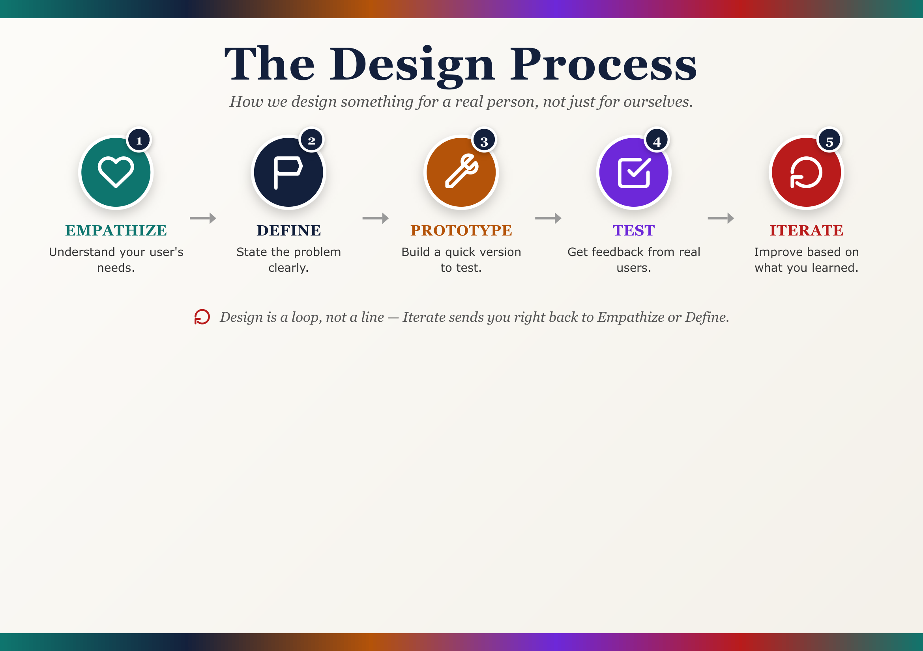

REMEMBER Design is a loop, not a line. Team StudyBuddy went back to Empathize and Define more than once — that's not a mistake, that's the process working.

Full Glossary
All 52 terms from the unit, A–Z.

Accessibility — How easily a product can be used by people with different abilities.
App Idea — A specific concept for an app that solves a real need for a real user.
App Lab — The Code.org tool used to build real, working apps.
Apps for Good — Apps designed specifically to help solve a real problem, not just for profit.
Barrier — Something that gets in the way of a user doing what they need to do.
Brainstorm — Generating as many ideas as possible without judging them yet.
Bug — Something in your app that doesn't work the way it's supposed to.
Button — A UI element a user taps or clicks to trigger an action.
Category — A group of related ideas or items, organized to be easier to think about.
Code.org / Code Studio — The website (studio.code.org) where most hands-on project work happens.
Competitor — An existing app or product that solves a similar problem to yours.
Criteria — The specific standards a solution needs to meet to be successful.
Debug — Finding and fixing something that isn't working correctly.
Define — Clearly stating what problem you're solving and for whom.
Design Mode — The part of App Lab where you build a screen's visuals before adding code.
Design Rationale — The reasons behind a design decision — the WHY, not just the WHAT.
Dropdown — A UI element that shows a list of options when tapped.
Empathy — Understanding and sharing another person's feelings or perspective.
Ethical — Doing what's right and fair, especially with users and their information.
Evidence — Specific facts or details that support a design decision.
Event — Something a user does (like tapping a button) that tells the app to respond.
Feature — Something your app does or offers, whether finished yet or not.
Feedback — Specific, useful comments from someone else about how well something is working.
Icon — A small picture or symbol representing an action or piece of information.
Inclusive — Designed to work well for as many different kinds of people as possible.
Insight — A useful realization about a user that explains why they need something.
Interview — Asking someone questions directly to learn about their needs or habits.
Iteration — Making a design better through repeated rounds of trying and improving it.
Link (Screens) — Connecting one screen to another so tapping something moves the user.
Market Research — Looking at what already exists to understand what works and what's missing.
Navigation — How a user moves between different screens or sections of an app.
Need — Something a user requires from a product for it to actually work for them.
Opportunity — A chance to solve a problem or make something better for a user.
Paper Prototype — A version of an app made entirely out of paper, used to test an idea.
Perspective — Seeing a situation from someone else's point of view.
Presentation — Sharing your work and explaining your process to an audience.
Prioritize — Deciding what to work on first based on what matters most.
Prototype — An early, rough version of a design built to test an idea.
Reflection — Thinking back on what worked, what didn't, and what you'd change.
Responsible — Making design choices that consider the wellbeing and rights of users.
Revise — Changing something to make it better, based on feedback.
Screen — One individual view or page within an app.
Screen Flow — The path a user follows moving from one screen to the next.
Section / Join Code — The class-specific code students enter to join the teacher's Code.org section.
Stakeholder — Anyone who has an interest in or is affected by a project.
Test — Having a real person try to use your design so you can see what works.
Text Input — A UI element where a user types information into an app.
User — The person a product or design is actually made for.
User Interface — The screens, buttons, and controls a person sees and touches.
User Profile — A description of a specific person's age, abilities, habits, and needs.
Usability — How easy and pleasant something is to actually use.
Visual Hierarchy — Arranging elements so the most important thing is noticed first.

Are You Ready to Present?
A self-check before your final App Presentation.

☐ Design Process Explanation — Can I clearly explain the user need, my research, and how my idea changed over time — with real examples?
☐ Working Digital Prototype — Are all my planned screens built and linked so someone else could navigate through my app easily?
☐ Feedback Incorporation — Can I point to at least one specific change I made because of real feedback?
☐ Bugs/Features Handling — Did I track my bugs/features list and actually fix or add the most important ones?
☐ Presentation Delivery — Can I present clearly, covering every required part, within the time given?
☐ Reflection — Do I have an honest reflection — a real strength AND a real area I'd improve?



You Started With Empathy.
You're Finishing With a Real App.

From one honest conversation about a real problem, to sketches, to feedback, to bugs, to a working prototype — that's the whole design process, and you did every part of it. Team StudyBuddy's journey was made up. Yours wasn't.

